

Azure SQL Database

Hands-On Lab

Configuration Guide  
Version 1.0

09/24/2015

Prepared for: Guy Haycock

Azure SQL Database

Prepared by: Prowess Consulting

Table of Contents

Architectural Overview 3

Lab-Configuration Prerequisites 3

Connecting Your Azure Account 5

Deploying a New WingtipTickets Tenant Environment 7

Appendix: Explanation of New-WTTEnvironment Parameters 12

Appendix: Explanation of Web.config Properties 13

Table of Contents

Architectural Overview 3

Lab-Configuration Prerequisites 3

Auto Provision A WingTip Ticket Site 5

# Architectural Overview

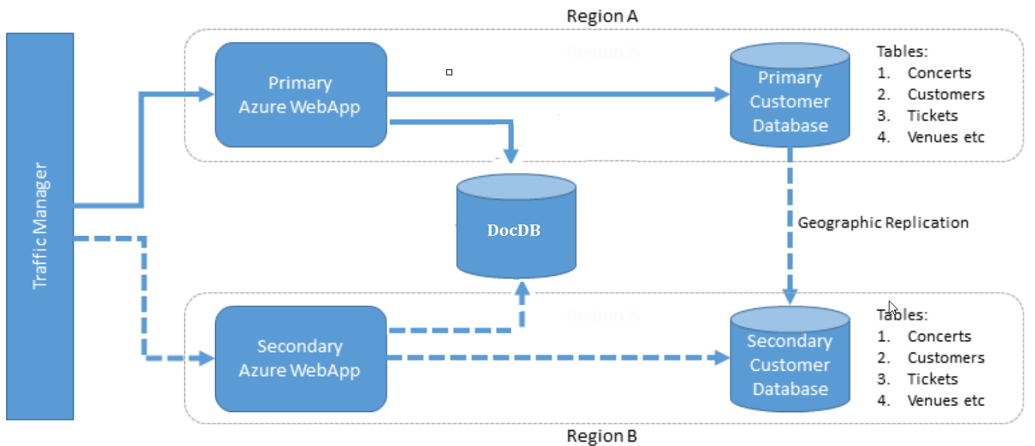

**Figure 1** Overall architecture of the various lab components

# Lab-Configuration Prerequisites

**Table 1** Lab-configuration prerequisites and setup instructions

| **Prerequisite** | **Setup instructions** |
| --- | --- |
| **Microsoft account** | 1. If you don’t already have a Microsoft account, browse to [http://account.live.com](http://account.live.com/) 2. Click **Sign up now**. |
| **Microsoft Azure account** | 1. If you don’t already have an Azure account, browse to <http://azure.microsoft.com/en-us/pricing/free-trial/> 2. Click **Try it now**. |
| **Microsoft Azure PowerShell** | 1. Browse to <http://azure.microsoft.com/en-us/downloads/> 2. Under Command-line tools, Windows PowerShell, click **Install**. 3. Verify that the version being installed is at least 0.9.7 (released August 24, 2015). |
| **Deployment scripts** | Unzip scripts.zip to a local folder (for example, c:\scripts). |
| **Microsoft Power Query for Excel (optional)** | If Power Query for Excel is not installed, and you’d like to complete the Auditing section in the hands-on lab (HOL) manual, download and install Power Query from <https://www.microsoft.com/en-us/download/details.aspx?id=39379>. |
| **Microsoft SQL Server Management Studio (optional)** | If SQL Server Management Studio is not installed, and you’d like to run queries against the databases, download and install SQL Server Management Studio from <https://www.microsoft.com/en-us/download/details.aspx?id=42299>. The package is listed as SQLManagementStudio_<X86/X64>_ENU.exe |
| **Microsoft Visual Studio (optional)** | If Visual Studio is not installed, and you’d like to explore any of the source code, download and install Visual Studio from <http://go.microsoft.com/?linkid=9832446&clcid=0x409>.  Unzip sourcecode.zip to a local folder (for example, c:\sourcecode). |
| **Microsoft Azure .NET SDK (if installing Visual Studio)** | 1. Browse to <http://azure.microsoft.com/en-us/downloads/> 2. Under SDKs, .NET, select the installer for your version Visual Studio e.g. **VS 2013 Install**. |

# Auto Provision a WingTip Ticket Site

1. Clear your cookie and cache of your browser and close the browser.
2. Open a newbrowser and navigate to <http://wingtipticketsprovisioning.cloudapp.net/> and click on **Create Account**

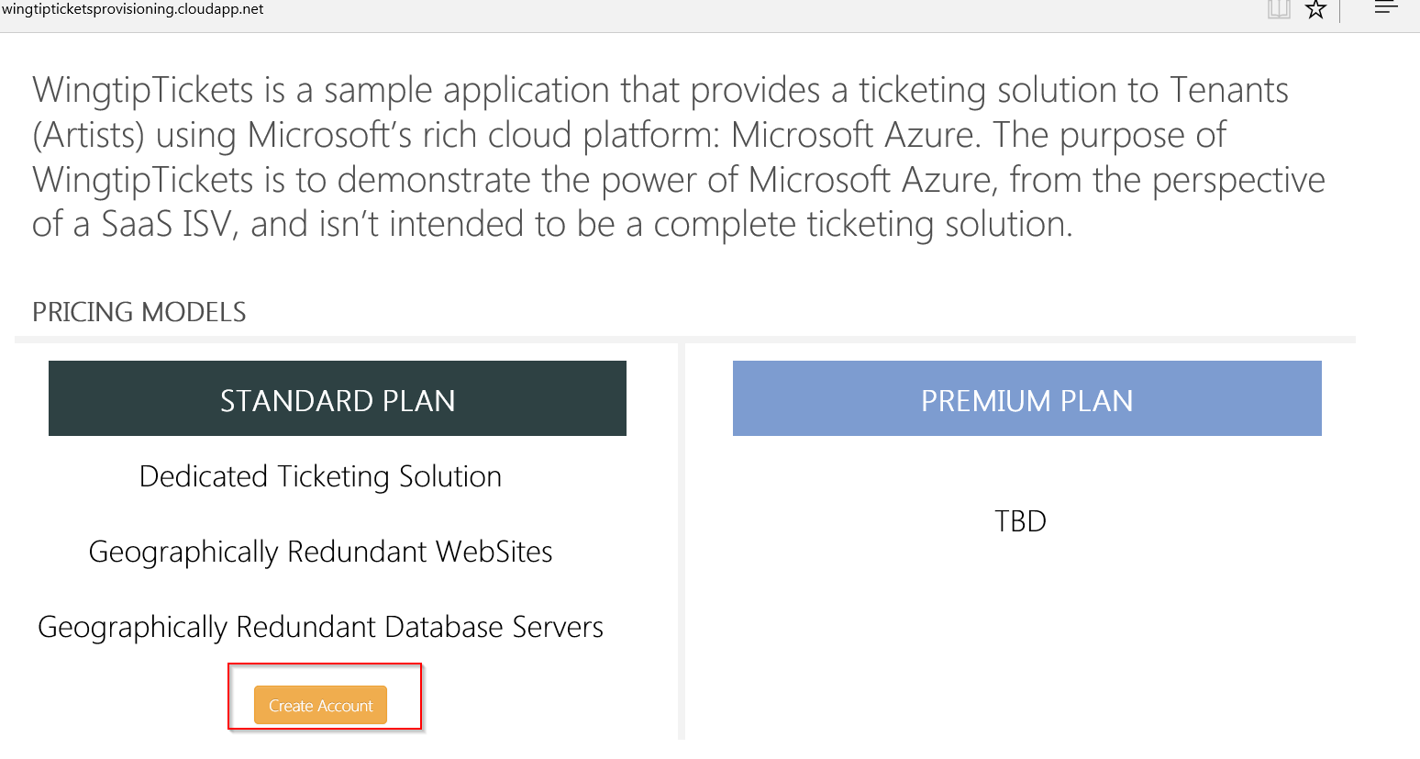

1. Choose Work/School Account or Microsoft Account based on your account type:

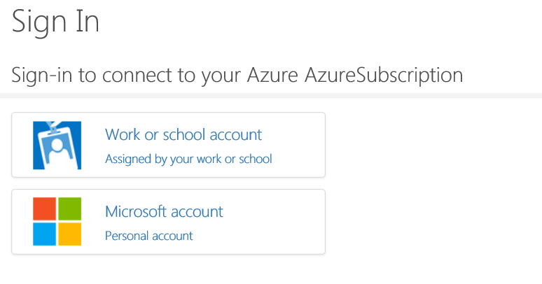

1. Type in your Directory Name like the example below in the box

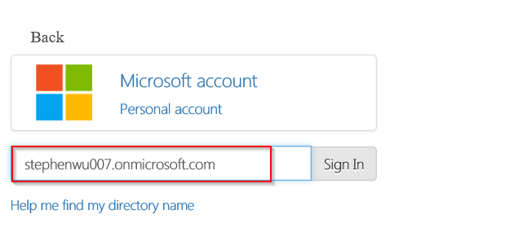

You can find your Directory Name by:

1. logging into <https://manage.windowsazure.com>
2. Click on Active Directory icon on the left-hand pane
3. Click on the Default Directory of the listed directory on the right-hand pane
4. Click on Domain

Your Directory Name should be similar to the one below:

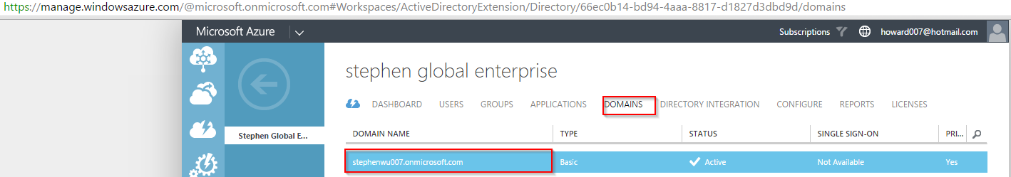

1. Fill out the info shown in the picture below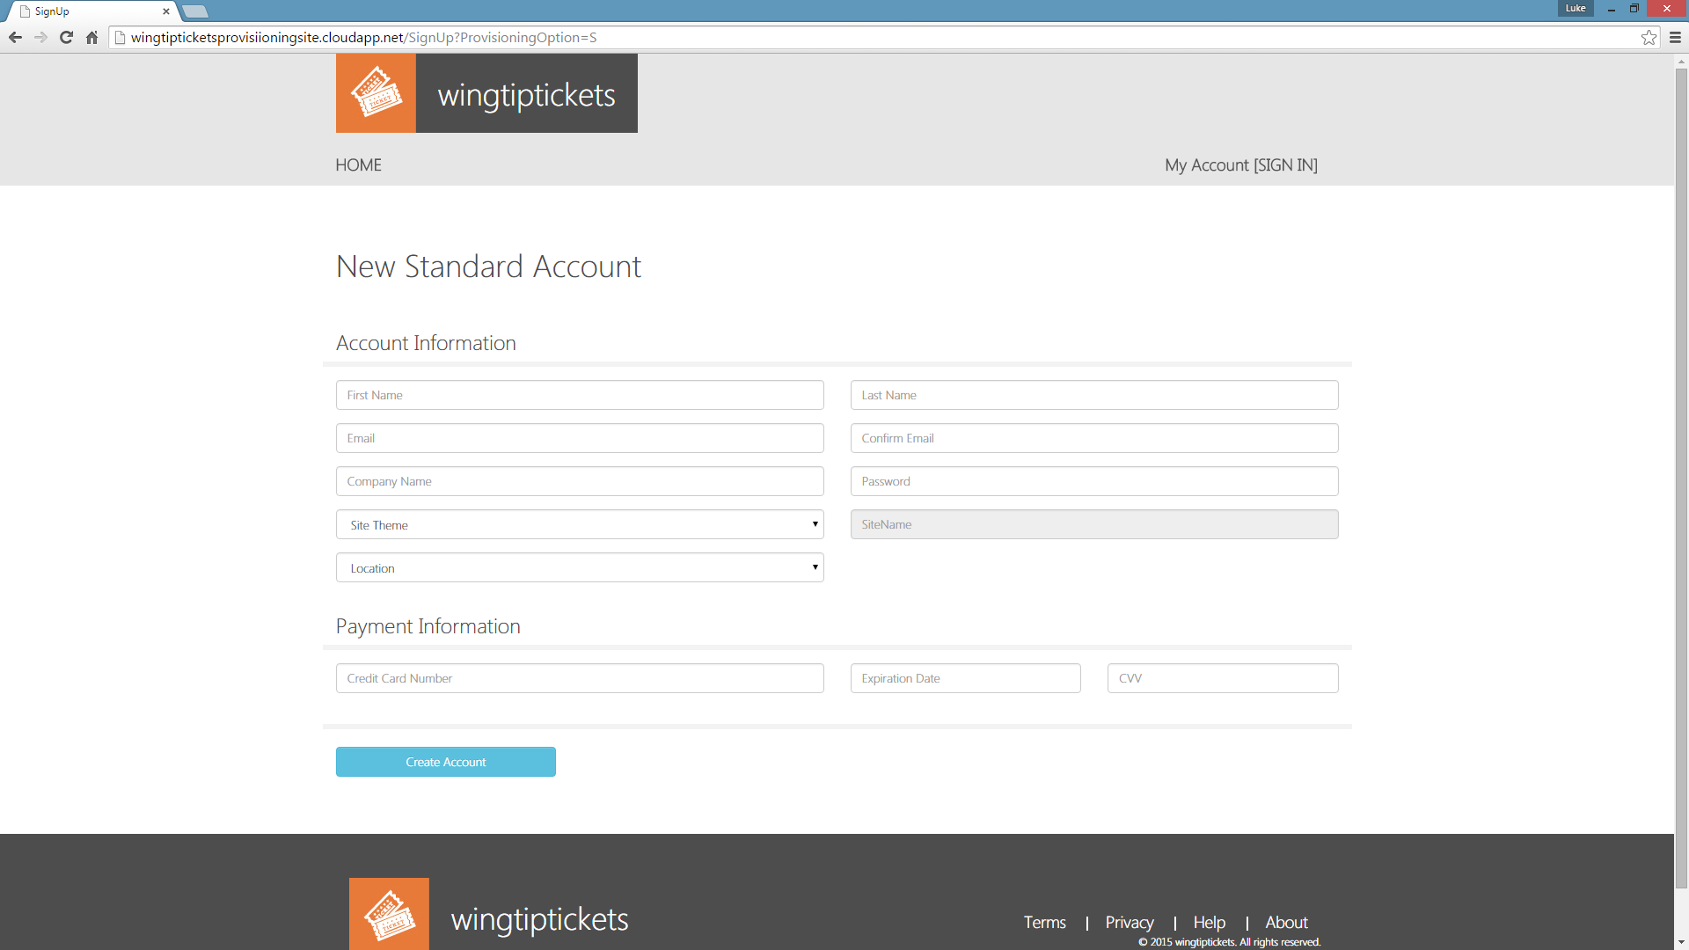 The New Tenant details are captured as follows:

* Account Information
  + First Name*
  + Last Name*
  + Email Address*
  + Confirm Email Address* (must match Email Address)
  + Company Name
  + Password*
  + Site Theme*
  + Location*
* ~~Payment Information~~ (**Ignore**)
  + ~~Credit Card Number~~
  + ~~Expiration Date~~
  + ~~CVV~~

*\* Denotes mandatory fields*

**Note 1:** The Location field specifies the Data Center region that will be targeted for the deployment. If the selected location does not support Db v12.0, then the next compatible region will be automatically assigned for the Tenant.

**Note 2:** The read-only SiteName field will be automatically generated based on the First and Last name, as well as the selected Site Theme.

Once the Tenant details have been captured, click on **Create Account.**

The Tenant Account is then created and the user is taken to the Account Information page. A list of Azure services are displayed along with their real-time provisioning status. Once each service has been successfully created, its status will change to “Deployed”.

**Note 1:** Database servers and website components have Primary and Secondary (fail-over) servers. Routing for this is handled by the traffic manager component.

1. Allow a few minutes for all services to be deployed.

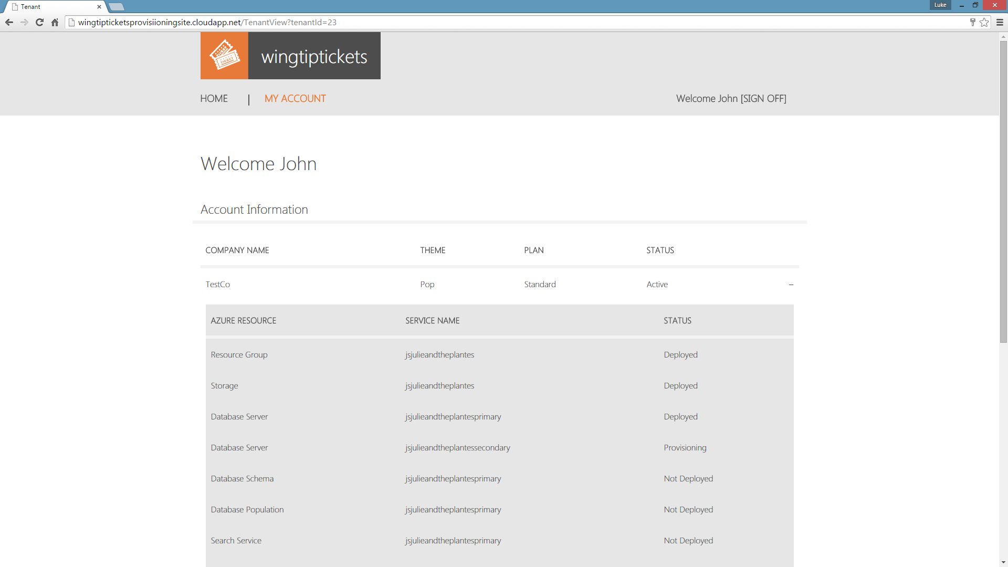

1. Once all of the services have been deployed, then provisioning has been successful and the Tenant site can be accessed.

To open and view the newly created Tenant Site, the site URL must be understood, which is comprised as follows: ***sitename*.trafficmanager.net**

The **site name** can be found next to the Traffic Manager Service item on the Account Information page at the bottom of the list of services:



Therefore the Tenant site URL in this example would be: [jsjulieandtheplantes.trafficmanager.net](https://www.jsjulieandtheplantes.trafficmanager.net)

